SUBJECT: SOFTWARE DEVELOPMENT SYSTEM

TOPICS : CORONA MANAGEMENT SYSTEM

INTRODUCTION:

The first confirmed cases of SARS-CoV-2 in Spain were identified in late February 2020 (1). Since then, Spain became, by the end of March, the third most affected country worldwide after the United States and Italy and recorded the second number of deaths due to the SARS-CoV-2 pandemic after Italy (2). Since March 16th, lockdown measures oriented on flattening the epidemic curve were in place in Spain, restricting social contact, reducing public transport, and closing businesses, except for those essential to the country’s supply chains (3). However, this has not been enough to change the rising trend of the epidemic. For this reason, a more restrictive lockdown was suggested (4), and eventually undertaken by the Spanish Government on March 30th (5).

Data visualisation is an important tool for exploring and communicating findings in medical research, and specially in epidemiological surveillance. It can help researchers and policy makers to identify and understand trends that could be overlooked if the data were reviewed in tabular form. We have developed a Shiny app that allows users to evaluate daily time-series data from a statistical standpoint. The COVID19-Tracker app systematically produces daily updated data visualisation and analysis of SARS-CoV-2 epidemic data in Spain. It is easy to use and fills a role in the tool space for visualisation, analysis and exploration of epidemiological data during this particular scenario.

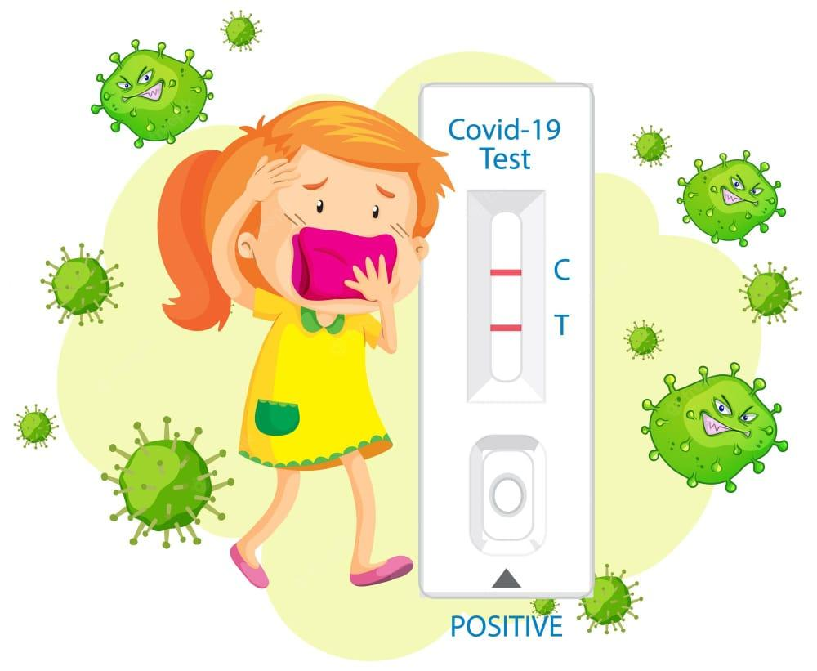

DATA SOURCES:

We collected daily data on COVID-19 diagnosed cases, intensive care unit

(ICU) admissions, and mortality, from February 24th onwards. Data is collected automatically every day daily from Datadista github repository (7). This repository updates data according to the calendar and rate of publication of the Spanish Ministry of Health/Instituto de Salud Carlos III (8). Data corresponding to the available number of ICU beds in Spain (year 2017) are also obtained from the database.



APPLICATION:

Projection:

For the evaluation of the observed trends of the accumulated number of cases, we used a classical quasi-Poisson regression model (9), allowing for over-dispersion and with a logarithmic link function, evaluating the existence of a quadratic effect. The two models are described as follows: Model 1: log(E(ct))=β0+β1t Model 2: log(E(ct))=β0+β1t+β2t2 where t = 1, 2, …, T represents the time unit (from the first observed day until the last, T consecutive days in total), and it assumes that ct, the observed cases, are distributed following a quasi-Poisson probability law. Estimated parameters and their standard error are used to obtain the predictions in the observed period of time but also the short-term projections, computing 95% confidence interval (95%CI)or the expected number of cases. The analyses have been carried out using R version 3.6.3.



INTERVENTION ANALYSES:

To assess the effect of the lockdown on the trend of incident cases, admissions in ICU intensive care units, and mortality, we used an interrupted time-series design (10). The data is analysed with quasi-Poisson regression with an interaction model to estimate the change in trend:

log(E(ct))=β0+β1t+β2 lockdown+β3t∗lockdown

where t =1, 2, …, T represents the time unit (from the first observed day until the last, T consecutive days in total); and lockdown is a binary variable that identifies the periods before after the alarm status decree (0 = before Mar 15th, 2020; 1 = after Mar 16th, 2020). The analyses have been carried out using R, version 3.6.3. We should acknowledge that this is a descriptive analysis without predictive purposes. For an easy interpretation, and comparison of the effectiveness of lockdown measures between countries, a linear trend is assumed before and after the lockdown. The changes in the definition of diagnosed cases have not been taken into account, nor has the reduction in the susceptible population because of the lockdown. Therefore, the incident cases are modelled directly instead of the incidence rate, assuming that the entire population is at risk. Although not accounted for residual autocorrelation, the estimates are unbiased but possibly inefficient. This analysis is accessible on the Intervention menu, displaying trends in a time-series plot before and after the lockdown for COVID19 diagnosed cases, ICUs, and mortality (Figure 3). The daily percentage (%) mean increase and its 95%CI are also reported. Results are available nationwide.

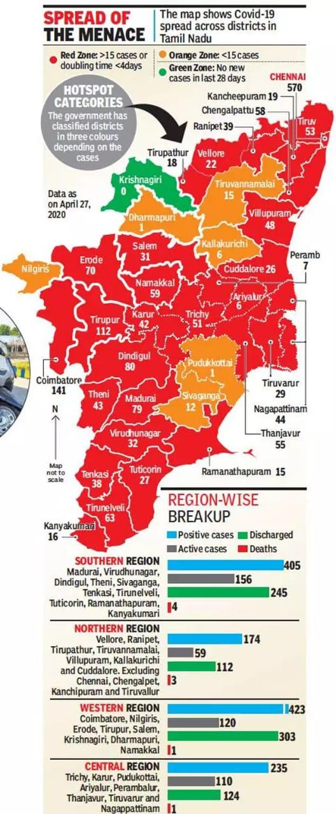

FURTHER DEVELOPMENT:

So far, the COVID19-Tracker app has been very well received online, with a large number of connections generating an outsized memory usage on our server

We are currently planning to improve the app by uploading shortly new applications for data visualisation and analysis, which may help for a better understanding of the SARSCoV-2 epidemic data in Spain. Moreover, the COVID19-Tracker app could also be extensible to data visualisations across other countries and geographical regions.

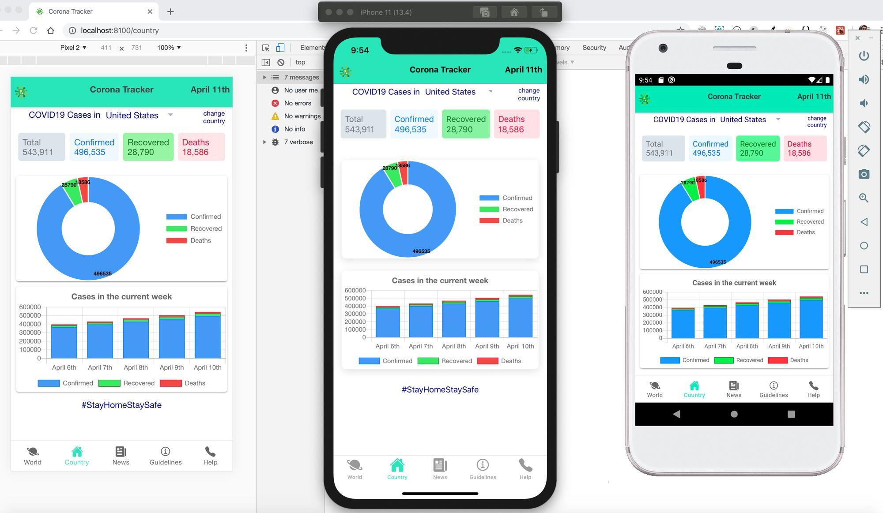

TABULATION:

TABLE 1 | Socio-demographic characteristics of participants. Variable Count (n) Percentage n = 1,000 (%) Region Jazan 748 74.8 Asser 252 25.2 Gender Male 461 46.1 Female 539 53.9 Age groups <30 years 559 55.9 ≥30 years 441 44.1 Education Middle school or less 26 2.6 High School 179 17.9 Bachelor Degree 634 63.4 Master/Ph.D./above 161 16.1 Occupation Doctor 76 7.6 Nurse 51 5.1 Pharmacist 240 24.0 Other Employed 238 23.8 Unemployed 123 12.3 Students 272 27.2 n, Number of participants. symptoms of infection and complications, its perceived threat, and high-risk population. Respondents were allowed to choose more than one option from the choices given according to their understanding and conscience. The results indicated that the majority of respondents had heard of and were aware of COVID-19 disease. Most of the participants (97.7%) correctly identified human-to-human transmission (contaminated person TABLE 2 | Awareness about COVID-19, its symptoms, transmission, and complications. Variable Count (n) Percentage n = 1,000 (%) 1. Heard of COVID 19 Yes 987 98.7 No 13 1.3 2. COVID 19 is a contagious life threatening disease Yes No 996 4 99.6 0.4 3. Incubation period 2–14 days 957 95.7 3 weeks 63 6.3 ≥1 month 11 1.1 Don’t know 32 3.2 4. Reliable source of information\* Health organisation 896 89.6 Healthcare professionals 579 57.9 Social media 155 15.5 Television/you tube 124 12.4 Newspaper/Poster 30 3.0 Family/friends 27 2.7 Don’t know 9 0.9 5. Mode of transmission\* Human-to-human transmission 977 97.7 Animals contact 229 22.9 Seafood and live animal 128 12.8 Fast food 93 9.3 Domestic animal 45 4.5 Don’t know 24 2.4 6. Symptoms of COVID 19\* Difficulty in breathing 909 90.9 High temperature/Fever 898 89.8 Cough 839 83.9 Sore throat 542 54.2 Tiredness 531 53.1 Pain in the muscles 343 34.3 Runny nose 217 21.7 Common cold 203 20.3 Nausea/Vomiting 179 17.9 Don’t know 20 2.0 7. Complications\* Pneumonia 794 79.4 Kidney failure 228 22.8 Sepsis and septic shock 76 7.6 Visual/Memory loss 18 1.8 Death 549 54.9 Don’t know 123 12

